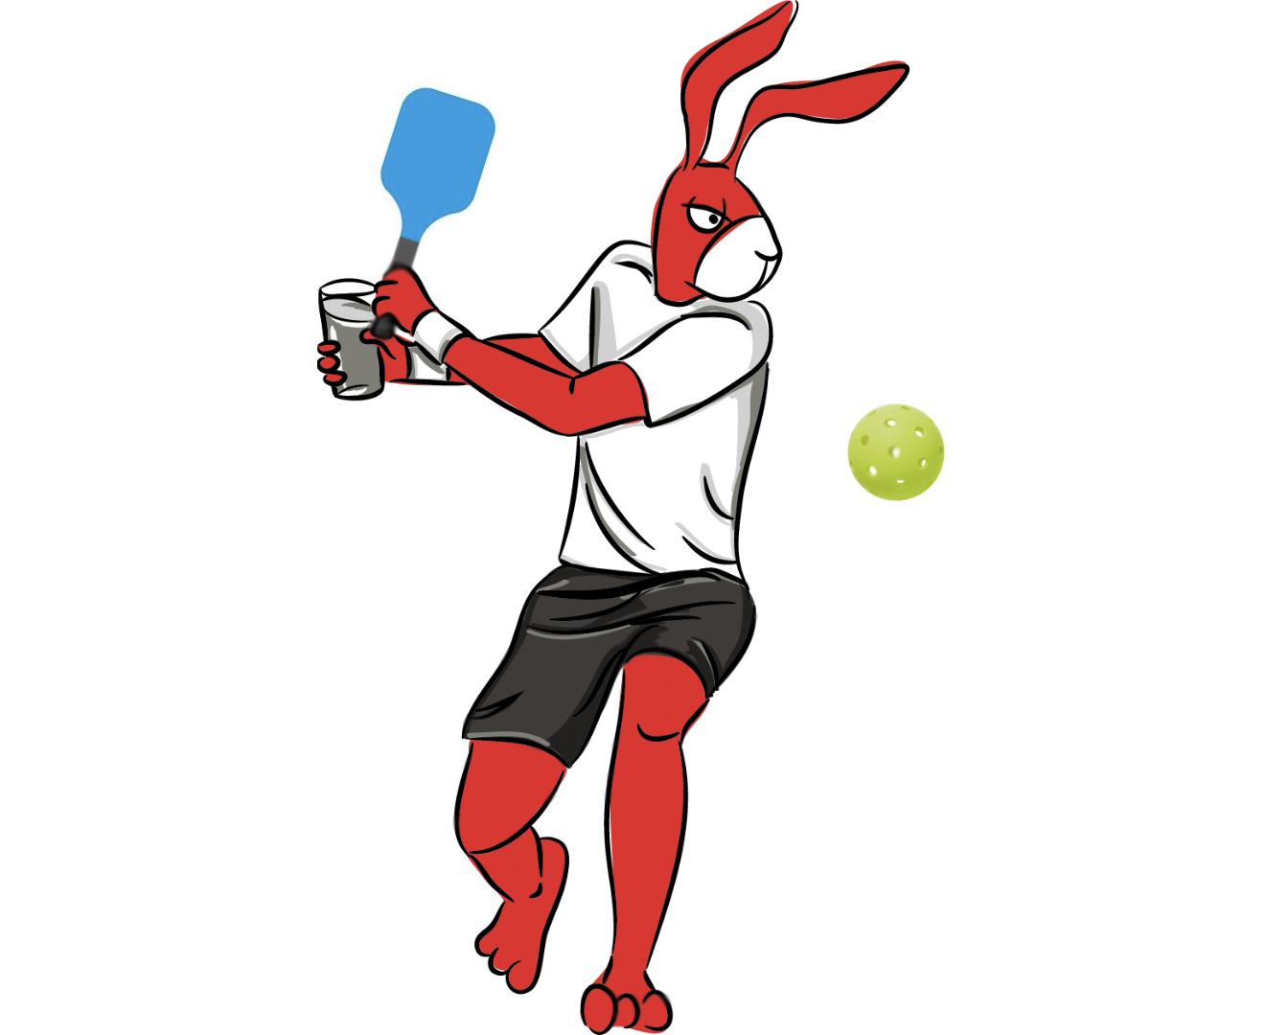
The Rules of Red Hare Pickleball

The rules aren’t complicated but if you don’t read them, you run the risk of looking bad so READ UP!

The winner of the night’s match will be the team that wins the most individual matches. The team that wins the best 2 out of the 3 matches wins that week’s overall team “meet”. Even if a team wins Men’s and Women’s Doubles, the third line of Mixed Doubles will need to be completed in full for tiebreaker purposes at the end of the regular season.
A “meet” consists of three (3) separate best 2 out of 3 matches: 1 men's doubles match, 1 women's doubles match and 1 mixed doubles match.

Note: A refund of $55 will be granted if the player requests one on or before the Sunday prior to the first match of the season. Said player cannot participate in season play.
ROSTERS
TEAM ROSTERS
Each team must have a minimum of 6 players. Teams must consist of at least 3 men and 3 women per team, but there is no limit to the number of players a roster can hold. For teams with only two available men or women for that week we will allow a player to play on multiple lines. For example, if a team only has two available men for a match, one of the players is allowed to play both Men’s Doubles and Mixed Doubles. This is a fun, social league and we want to try our hardest to prevent any defaults due to lack of available players. This is only allowed for teams with two available players of that gender per week.
- Divisions
  - Each facility may have different variations in the available divisions. Some divisions will have ‘open’ playing levels, while others may have “Beginner/Intermediate and Intermediate/Advanced” divisions.
  - *Teams must play in the correct playing levels. This means that teams must play in the level of their best player*
    - Ex: Tim is a 4.0 player, but wants to play with all his friends that are 2.5 players. This team must play in a division where the minimum playing level is 4.0. Teams who do not follow this guideline will be disqualified from playoff contention and potentially subsequent seasons.
2. Determining Ratings of Players
- If a player has a computer generated USTA rating, they must compete at that rating.
- If a player is using an accepted self-rating for USTA League play, that player must compete at that level in the RHBCT League. When ratings are published for USTA League play, that player must play at the published rating.
- If a player does not compete in USTA Leagues and does not have a rating, USTA Atlanta will allow a player to self-rate for the RHBCT League using the guidelines found at the end of these rules.
3. Adding Players
Teams may add players throughout the regular season to their roster. There is no prorated rate. A player may not be added after the last regular season match has been played. The rating of an added player must be within the boundaries of that team’s level of play. All players must be paid IN FULL before stepping on the court or the line(s) in which that player played will be defaulted. Teams who play non-registered players are subject to team suspension.

SCORING
1. The Match

Every week, each team will play against an opposing team. We call this a “meet”. Each meet consists of three matches: men’s doubles, women’s doubles and mixed doubles. Captains must submit lineups to the other captain prior to each set.

The winner of the night’s meet will be the team that wins the best 2 out of 3 individual matches. Even if a team wins Men’s and Women’s Doubles, the third line of Mixed Doubles will need to be completed in full for tiebreaker purposes at the end of the regular season.

2. Set Scoring

The set scoring will be as followed: Best 2 out of 3 sets to 15 points. If the sets are tied 1-1, a third set to 11 points will be played.

THE NITTY GRITTY
- Order of Play
One court: Starting with Men’s Doubles, followed by Women’s Doubles and ending with Mixed Doubles. The match must end with Mixed Doubles. If both captains agree, women’s doubles may start the night’s matches.
2. Exchanging Lineups
Captains will exchange lineups with the opposing captain prior to each set showing who will be playing for their team. Once a player has begun play, the player must complete at least one set before a substitution is allowed. The official match start time is 6:30 PM each scheduled WEDNESDAY (Thursday for Windward Lake Club)
3. Warm-ups
Men’s Doubles must warm up at 6:30 PM for no longer than 5 minutes. Players may warm up for no longer than 5 minutes prior to the start of each match.
Captains are responsible for enforcing the 5-minute warm up rule.

4. Service Order & Change of Ends
The service order is determined by the spinning of the paddle. A player will ask the opponent to call the direction or letter on the bottom of the Paddle. The player/team who wins the spin may choose either: A. To be server or receiver of the first game of the match in which case the opponents will choose which side to start from or B. Choose the side they want to start on in which case the opponents would choose to either serve or receive first.
5. Substitutions
A team can substitute a player of the same gender into a set for any reason, if the following guidelines are met:
- A player must complete AT LEAST ONE SET before they are taken out of a set and replaced by a substitute.
- Once a player is replaced, he/she cannot return in that match. In doubles, the remaining player cannot change the side on which they receive or the service order.
Substitutions can be made at the conclusion of a point after one set has been played.
Substitutions cannot be made during a tiebreaker set.
A player who played in a same-sex doubles match can play in the subsequent mixed doubles match. See Rule #10.
6. Mulligans
Each player (including subs) in every individual match is allotted (1) one mulligan that can be used on any shot during the match. An active player must immediately announce they are using a mulligan after their team’s last point has been lost.
Mulligans can be used on the same point. (Ex: Team A loses a point and Becky on Team A calls a mulligan. The point is replayed and Team A loses the point again. If Becky’s partner, Cyrus, has an unused mulligan, Cyrus can call a mulligan and the point is replayed again.) In theory, four mulligans could be used in a row if all players on court have an unused mulligan.
7. Pickleballs
THREE Pickleballs will be provided to captains for the regular season. All balls that are needed will be included in the captain’s pack which will be provided to captains before the start of the first match. The designated home team will be responsible for providing the pickleballs each week. Balls should be used for the entire TEAM meet (all three matches of play).

8. Coaching
Coaching is allowed throughout the match as long as it does not interfere with continuous play. We encourage team members to safely stand along the court and support their team members.

9. Default Rules
Team default time: 15-minutes. The match default score will be recorded 3-0. The default play time for Men’s Doubles is 6:30 PM. The default play time for Mixed Doubles is 8:00 PM.
Player default time: 15 minutes. If a home or away team does not show up the score will be recorded for the present team 3-0. Please tell your players that once the men’s doubles set is completed, the women’s doubles players should immediately take the court for the five-minute warm up. The same applies for the mixed doubles match.
10. Mixed Doubles
Mixed Doubles players should not play in more than one full individual match per night. That means each team is required to have at least 3 men and 3 women ready to play each night. The exceptions to this rule are a lack of available players (see page 1) and substitutions. A player who has played in a previous match (women’s doubles or men’s doubles) may substitute in after the substitution requirements are met.
11. Rain
With the inevitable threat of rain, it is important that we try to finish all scheduled matches.
- If the match is a total wash, (no chance at getting on the court due to rain) at some locations we have built in an extra week to the schedule to try to play make-up matches. This built in week will allow teams to play matches that had previously been rained out during the season.
- If it begins to rain during a match, we would like to try to play rained out matches the following week AFTER YOU PLAY YOUR ORIGINALLY SCHEDULED MATCH. If there is time after your scheduled match, and both teams are able, please complete the match where you left off when it started raining.
  - It is the job of the captains to remember the scores of the incomplete match before resuming the following week.
Captains should call their facility to confirm playing conditions and communicate with their players with the exception of Piedmont Park (Dan Kester will be in touch with Piedmont captains). If a match is completely rained out, teams do not need to report to the facility and captains should confirm the match cancellation with one another.
Lights
- It is paramount that we get our matches started on time. Matches need to begin promptly by their assigned time.
  - If your match is scheduled for 6:30, you must be on the court by then.
Many of these facilities will not keep the lights on past their closing hours.
12. Entering Scores in TennisPoint
The captain of the winning team will enter scores at the end of the match. Please confirm with the opposing captain that scores are correct.
*Note: If incomplete matches remain at the end of the regular season, scores for said matches must be left at 0-0.

13. Registered Players Only

All players must be registered for the league in order to participate. Teams who play unpaid players are subject to disqualification from the league with no refunds given to all players on the team.
14. USTA Rules of Fair Play will be followed during all play.

DIVISION WINNERS
During the regular season, teams will play each of the other teams in their division. Division standings will be based on the won-loss record of completed overall meets. If the schedule does not allow for a final, division winners will be determined by the regular season meet outcomes (which are again determined by the won-loss record of completed overall meets.)
Ex) If Team A wins 2 out of 3 matches during their meet against Team B, that’s considered one win for Team A and one loss for Team B when determining teams’ won-loss records.
In the event of a tie:
The first tiebreaker to decide the winner of each division (or if there’s a final, which two teams will play in the final) is total individual matches won.

The second tiebreaker will be the best winning percentage (total games won divided by total games played). If there is still a tie, the winning team will be determined by the team that won the most total games during the season.

FRIENDLY REMINDERS
(1) The Red Hare Brewing Company Tennis League is a fun, recreational league. We remind all captains and players to be flexible, exhibit good sportsmanship and be willing to work with the other teams to make each league season a success.
(2) League administrators cannot verify all ratings and research players without a USTA rating prior to the start of the season. Please register for the division that suits your true skill level.
(3) Because this is a fun league, we don’t have a long list of rules; however, we do expect teams to play with integrity and not abuse the laid-back atmosphere of this league. Be kind. Have fun.
***All rules are subject to change***

